How to Study
Digits

________ Did you review your class notes?
_______ Did you go back to your lessons that you learned in class and work out each of the examples? (This is great practice)
How to get to your lessons that we learned in class:
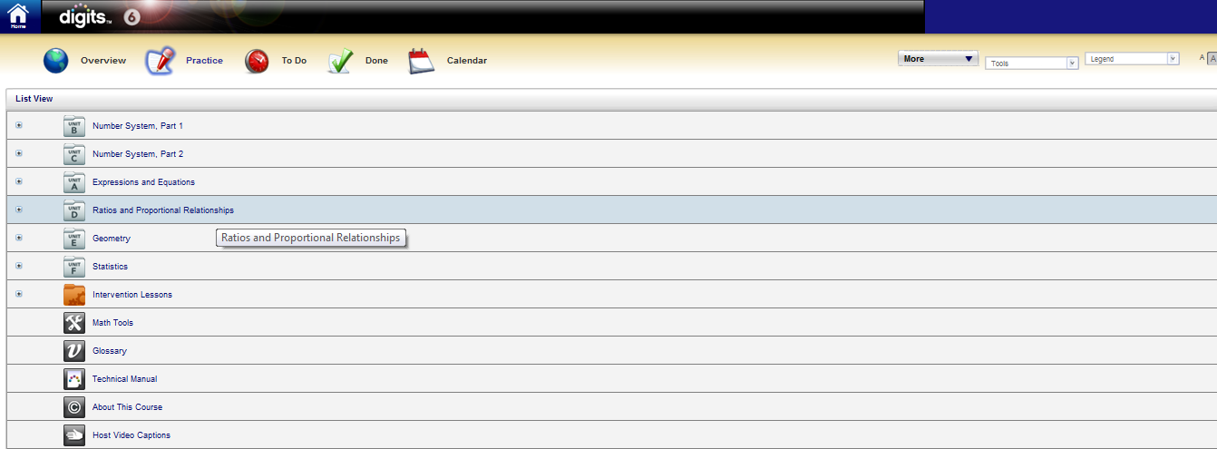
Click on “Practice” to get to your book (this is where all of your lessons are)
Click on the “Unit” that you are on.

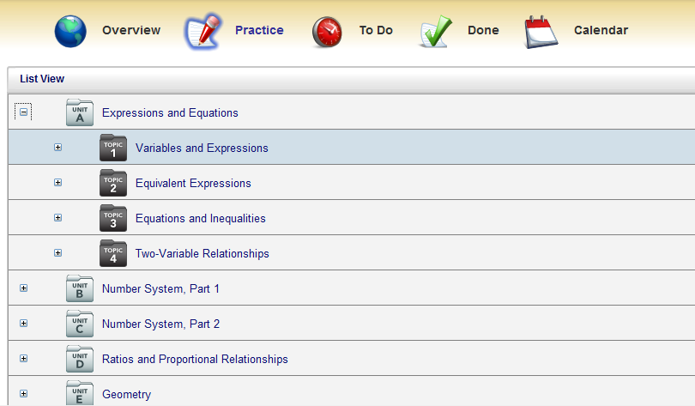
After you click on the “Unit” you are in, you then need to click on the Topic

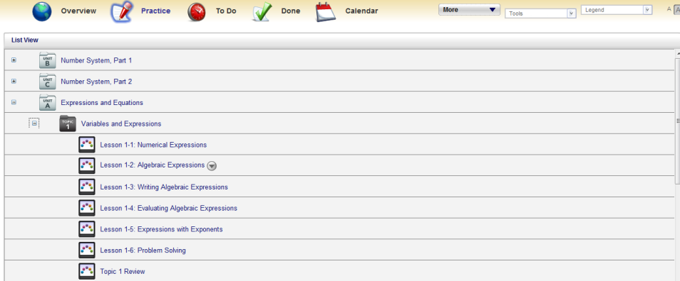
Last step is to click on the lesson you are looking for.

___________ Did you go back to your homework and try “similar exercises” for extra practice problems. (This is another great way to practice and study)
How to get to your homework that you already completed:
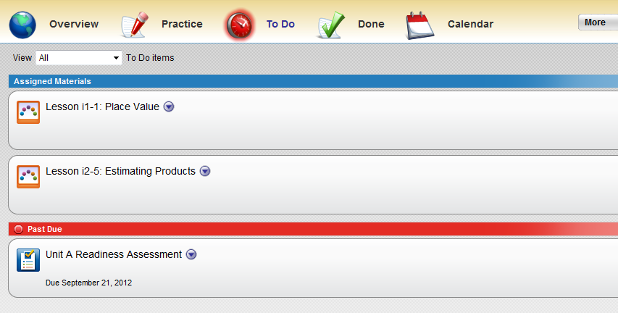
Click on “Done”
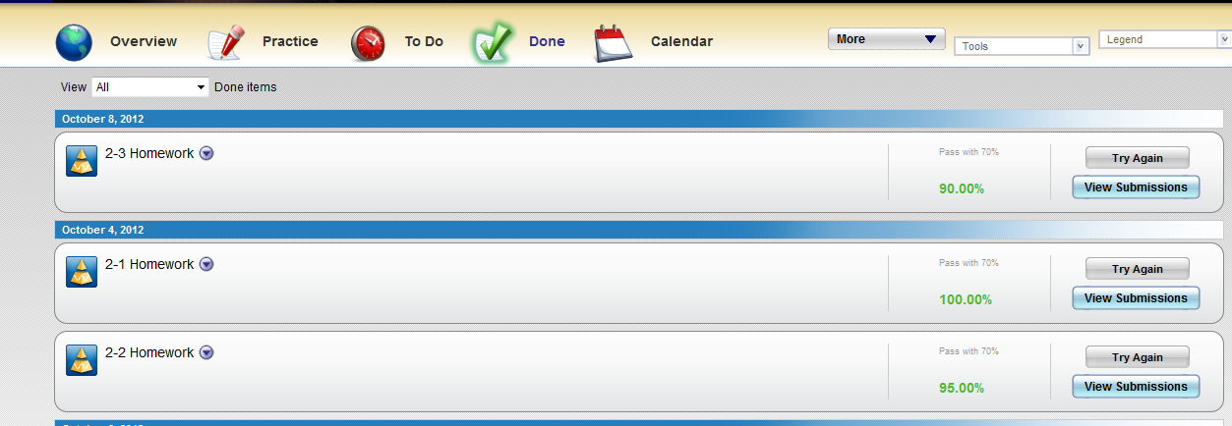
Find the homework that you want to work on and click on “try again”
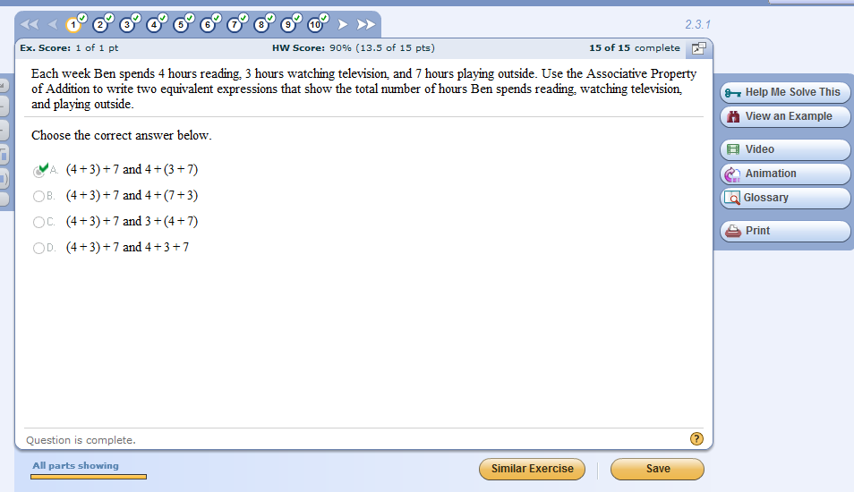
- Click on the question you want to work on.
- Click on “Similar Exercise” (this will give you a new problem for you to work on)

__________ Did you come in and check with Mrs. DeGennaro and/or Mrs. Sottosanti’s to see if your study guide is correct?
__________ Have you been looking over and reviewing your study guide?

- You should be going back to your notes, lessons and homework as often as you can.
  - DO NOT WAIT UNTIL THE NIGHT BEFORE THE QUIZ OR TEST!!!

