How to Complete Intervention/Journal Lessons
Digits
By: Mrs. Toni Marie DeGennaro
STEP 1:
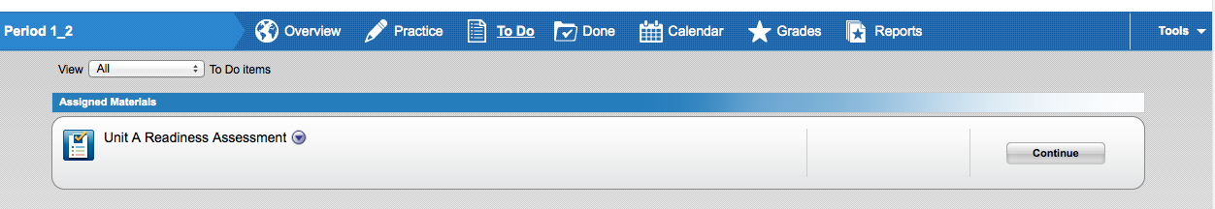
Second: Click on “continue”
First: Click on “to do”
*This will remain in your “to do” even after you finish all of your journals.
*If you do not have any Journals for this particular Readiness Assessment – the assessment will be in your “done” section.

STEP 2:
*Make sure you scroll down to see if you have other journals assigned to you.

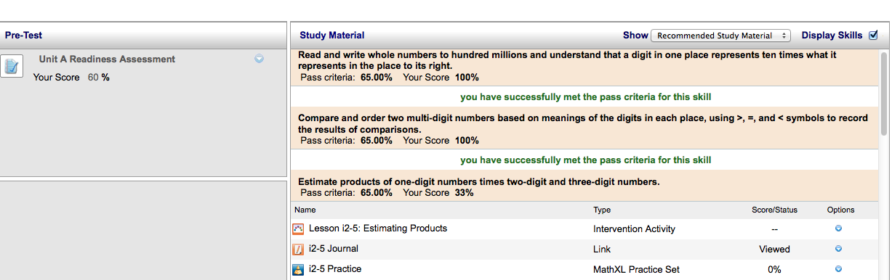
First: Click on the Journal (worksheet) and print it out.
*Acrobat Reader needs to be installed for these Journals to appear.

Second: This is the lesson you will need to click on as you are completing the Journal (worksheet).
You can be assigned up to 10 Interventions/journals.
*These are the journals that you do not have to do.

STEP 3: Follow the lesson online and complete Journal/Worksheet
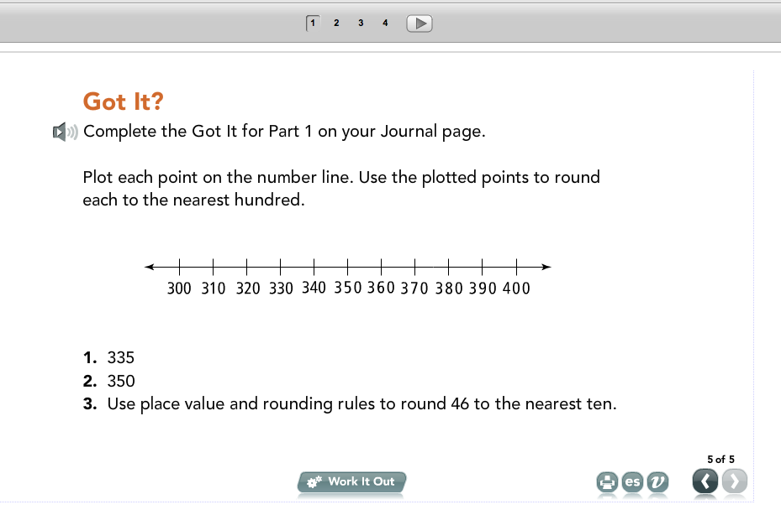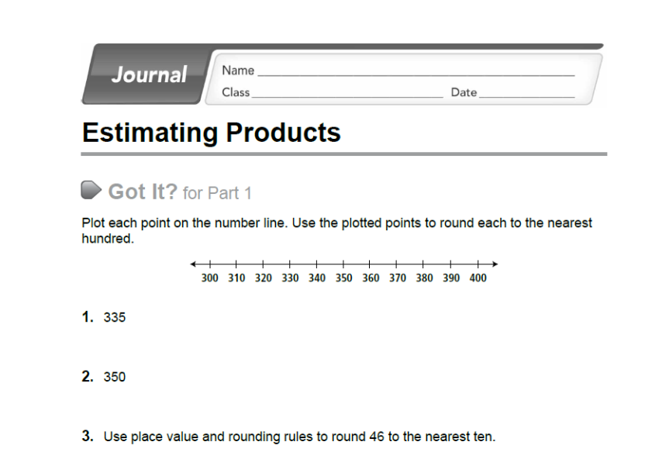
First: Start on Part 1
Second: Go through all the slides on Part 1 (work them out and check your answers to see if you are correct.)
Example: 1 of 5, 2 of 5 until you come to the last slide 5 of 5
When you come to slide 5 of 5 on your lesson it will ask to complete this question on your journal page.
The Journal Page will have that same question from your lesson.

First: Now you will start on Part 2
Second: Go through all the slides on Part 2 (work them out and check your answers to see if you are correct.)
Example: 1 of 3, 2 of 3 until you come to the last slide 3 of 3
STEP 4:
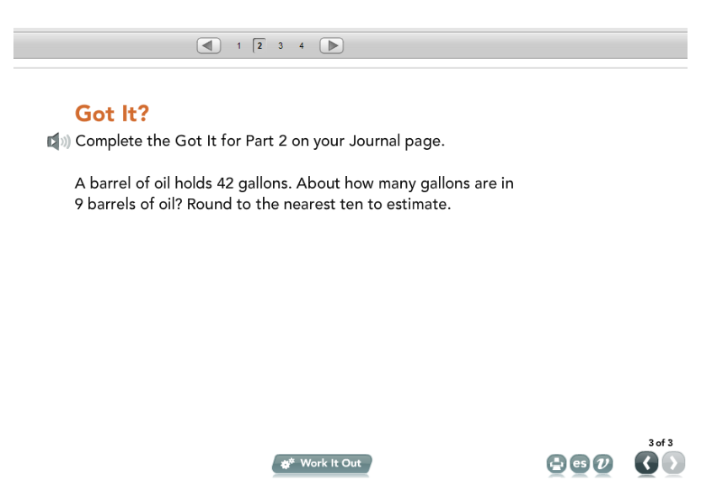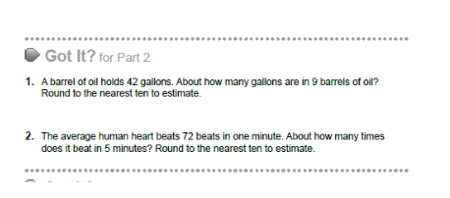
When you come to slide 3 of 3 on your lesson it will ask to complete this question on your journal page.
The Journal Page will have that same question from your lesson.

STEP 5: Go back your Lesson and complete part 3 along with your Journal/worksheet for Part 3
STEP 6: Go back your Lesson part 4 and the 2nd page (Lesson Check ) of your Journal/Worksheet page.

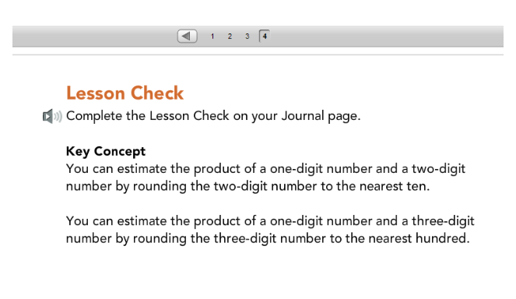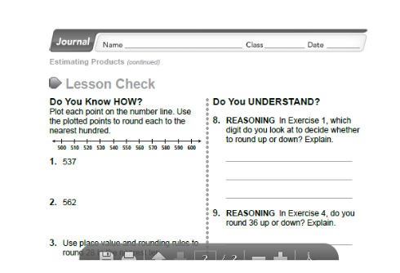
When you come to part 4 on your lesson it will ask to complete the “Lesson Check” on your journal page.
This is when you complete the entire 2nd side of your Journal sheet. This is where we will be able to see if you have mastered this particular skill.

STEP 7:Once you finish going through the entire lesson,
click “ Submit for Grading” 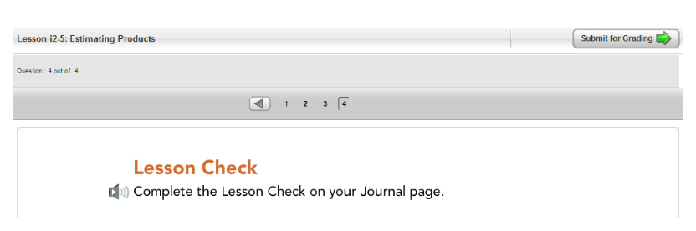

STEP 8: Once you complete the worksheet (both sides), hand in for grading.

